**THE HUMAN COST OF CONFLICT RELATED SEXUAL VIOLENCE.**

A report from **Zipporah Adenike Omowummi Oladejo**

**FOUNDER, WIDOWS REJOICE MISSION, LAGOS, NIGERIA.**

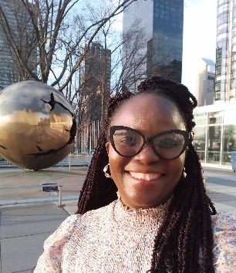

Side Event at **Commission on The Status Of Women (CSW68**), West Terrace Room, UN Headquarters, New York.

**KEYNOTE ADDRESS:**

Margot Wallstrom, Former Deputy Prime Minister of Sweden and UN Special Representative on Sexual Violence in Conflict.

**PANEL**

**Meaza Gebremedlin,** HR Defender and Advocate in Tigray

**Dr. Cochar Elkayam Levy,** Chair of the Dvora Institute For Gender and Sustainability Studies and the Civil Commission on 7 October Crime against women and children.

**Masla Efrosinina**, Co-founder of Marsha fund. Honorary Ambassador of the UNFPA and Ukrainian TV Presenter and Actress.

**Fawzia Koofi**, Former Second Deputy Speaker of the Parliament in Afghanistan and women rights activists.

**Explainer:** Conflict related Sexual Violence is a specific type of Gender Based violence which includes rape, sexual slavery, forced prostitution, forced pregnancy, forced marriage and any other form of sexual violence that is directly or indirectly linked to a fragile state, war or conflict.

**As leader and advocate of Widows Rejoice Mission I feel passionately that unless we name widows and widowhood – a huge group of women at risk of violence: conflict widows are effectively made invisible by politicians, legislators and policy writers. For the purpose of drawing attention to widows in conflict zones and fragile states I will use the term ‘widows’ in this write-up.**

The main focus of the event focused on the human factor of conflict related Sexual violence in Nations across the globe, especially in conflict countries like Tigray, Sudan, Ukraine, Gaza and more.

**According to all the panelists, widows are being targeted for sexual violence**. They are also vulnerable to trafficking and many widows and their families are being trafficked and taken advantage of. There has been so much brutality against women, such as organ removal with infliction of acute pain and suffering.

**Many of the crimes of conflict related violence go unpunished and most peace agreements do not mention the women involved.**

**Conflict related sexual violence is recognized as a crime** and unfortunately the term has been manipulated and mis-used.  We therefore need to create scenarios where many things must change.

This is necessary because, in the 21st century, women are not allowed to go to school and many of the laws that will protect a woman have been abolished because, women and especially widows, are seen as second class citizens and nobodies. **For generations coming after us, Women of the 21 century must continue in their efforts to provide a decent legacy for all women, especially widows.**

**We must hold our leaders accountable through practical action**. That is, we need to see how we can change the world. Every woman must be alert about what is happening and use their platforms on a daily basis to write at least one message about injustice around the world.

According to the panelist on the Human Cost of conflict related violence, the fact remains that injustices are everywhere, especially in the places of war zones. **The situation has been so politicized that the human side of conflict related sexual violence is completely lost**.

**Many widows and women generally are mistreated sexually and only women understand such pain**. Therefore, we all need to understand each other's plight irrespective of our leadership position, social status and the country from where we belong.  **Education that is women and widows inclusive and aware is crucially needed.**

According to the panelist, it is so sad that **people generally have the negative perception that women deserve to live under male dominance in their culture or religion**. We must act against these perceptions. Words are just not enough and all women and widows must rise against Conflict related sexual violence and demand an end.

**Many victims of Conflict related sexual violence have died because they do not have access to medication and food.** The situation on ground is extremely bad because we are dealing with survivors of Conflict related sexual violence who are also highly traumatized.

Unfortunately, the community is not equipped well enough to rehabilitate these women who are survivors. **Widows are often blamed for the deaths of their husbands and forced to flee from their homes and land**. There is little financing to build health infrastructures that are essential for healing women who are survivors of conflict related sexual violence. This includes girls too.

The case of the pain and the suffering of Tigre women is a typical example of CRSV spoken about. The speaker affirmed that **In Tigray, the women are the backbone of the society and despite their strength these women face acute violence**. According to the panelist, its crucial to highlight how Tigray women had been forced to go through silent crimes of rape and violence committed against them including widows and girls.

**In this case, the panelist- advocate who lives in the Tigrayan diaspora mobilised and actively amplified the plight of Tigray women**. This was the only way of highlighting the violence against these women because throughout the conflict because the Tigray government shut down all communication channels, electricity and Internet**.   Legislators, policy makers and human rights organizations were effectively mobilized to rise up against the appalling abuses inflicted on Tigray women, widows and girls and the Tigray population in general.**

Affirming that there are over 250,000 women and young girls who are being sexually violated. These women are now having to deal with cervical cancer, pestila, internal bleeding and many other complications as a result of the sexual violence.

**In Tigray, It is sad to note that health facilities have been completely destroyed** and It is a tragedy that those affected by conflict related sexual violence do not have anywhere to go in order for healthcare.  Many of these women are now bedridden with many others resulting in taking their own lives owing to their desperation and feeling of helplessness. **The number of suicides continues to rise**.

**Members of the international community, human right defenders were urged to use all diplomatic tools available to them to impose the necessary sanctions against perpetuators of Sexual Violence. It must end!**

The panel called for **an international mechanism that will hold people that commit sexual crimes accountable in a court of law. Also CRSV crimes need to be dealt with quickly.** Otherwise **a woman can be re-traumatised over a long period of time waiting for a case to be made.**

We all have to use our collective power to protect one another and advocate for the protection of all women but especially those on the margins of life such as widows and their children.

**Panelists also addressed the sexual violence on Ukraine women**. Ukrainian women are going through domestic violence such as rape, torture and widespread violence. Many of these women have given up believing they have any redress. They want justice and also want to be heard because, they are being victimized. Many of these women don't even remember what has happened to them. **The Ukraine government is not doing enough for widows and vulnerable women in war. The women in Ukraine want justice for all women. All killers must be punished. Every sexual crime should be punished.**

The situation of the women (including widows in Sudan) was discussed. **Women in Sudan, many of who suffer for a long time after they have been raped, molested, kidnapped or trafficked never see support, healthcare or assistance.**

According to one of the panel members, the media failed to capture the severity of the issue and more journalists are needed to be trained to cover the issue of the dignity and privacy of survival of conflict related sexual violence.

**In conclusion, we all need to demand to be heard and speak out against the injustice of conflict related sexual violence and human trafficking. We must all raise a social media campaign for justice. We must be a collective voice to speak out against the crime and injustice of Conflict Related Sexual Violence which too often is conveniently forgotten.**

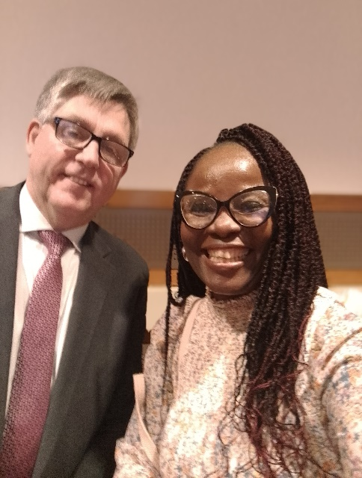

**Kevin Hyland, OBE (UK’s First and Former Commissioner against Slavery & Trafficking**

**and Zipporah Adenike Omowummi Oladejo at CSW 68**